|  |  |
| --- | --- |
|  |  |
|  |  |
|  | Report of Findings --  Efficient Devices for Compressed Air Blowing Applications |
| Submitted to | Geoff Wickes  Northwest Energy Efficiency Alliance |
| Submitted by | SBW Consulting, Inc.  2820 Northup Way, Suite 230  Bellevue, WA 98004 |
|  |  |
|  | October 13, 2016 |



Table of Contents

1. Introduction 1

2. Objectives 2

3. Methods of Investigation 3

4. Compressed Air Blowing End Uses 4

4.1. Waste Material Removal 4

4.2. Cooling 4

4.3. Drying 4

4.4. Extrusion Blowoff 4

4.5. Providing a Dry Environment 5

4.6. Parts Feeding 5

4.7. Parts Ejection 5

4.8. Ventilation or Exhaust 5

4.9. Static Control 5

5. Device Search 6

5.1. Air Saving Unit 6

5.2. Engineered Nozzle 6

5.3. Air Jet 7

5.4. Air Amplifier 7

5.5. Air Knife 7

5.6. Air Wipes 8

5.7. Multi-Nozzle Heads 8

6. Devices Competitive with ASUs 10

7. Performance Specification Development Feasibility 11

8. Recommendations 13

# Introduction

Compressed air is at once both a convenient means of delivering power to many different manufacturing processes and generally the most inefficient means of doing so. Among the many end uses for which it is used, open blowing is one of the most common and has one of the greatest potentials for being wasteful. It is not unusual for open blowing to be achieved by simply adding a section of pipe or tubing to a compressed air line at system pressure, fixing it in position aimed at the desired target and letting it blow continuously. The purposes of such a setup are many and varied. Examples include removal of waste material from machining processes; cooling of heated parts; drying of wetted parts; cleaning of parts in preparation for subsequent processes such as painting; cooling of overheating bearings or workers; or the positioning of parts in automated assembly lines.

Fortunately, several products that significantly improve the efficiency of blowing end uses over open pipes have been developed employing different methods. A new product on the market, the Air Saving Unit (ASU) has recently been introduced in North America. It has a fairly wide breadth of potential applications and competes with some of the other products that have been developed. This report presents the findings of an investigation into the availability of devices designed to reduce compressed air consumption in blowing end uses to be considered for inclusion in utility-sponsored energy efficiency programs and market transformation initiatives.

# Objectives

NEEA’s objective of promoting energy efficiency through utility efficiency programs and market transformation is served by the identification of cost effective technologies that can be employed to those ends. The purpose of this investigation is to:

1. Investigate the availability of devices designed to reduce the use of compressed air in blowing applications according to the following criteria:
   1. The device reduces the consumption of compressed air as compared to open blowing
   2. The device achieves or exceeds the effect desired from open blowing of compressed air in common applications
   3. The device can be retrofitted in existing systems
2. Examine the feasibility of developing a functional performance specification that could be used by NEEA to encourage development of devices that improve the energy efficiency of compressed air blowing applications
3. Develop recommendations for the next steps NEEA could take in transforming the efficiency of regional compressed air blowing applications.

# Methods of Investigation

In addition to knowledge of energy-saving devices for compressed air blowing applications we have gained from years of performing compressed air energy audits, we also performed an extensive internet search to identify devices adhering to the criteria specified in Section 2. Many manufacturers and distributors associated with such devices were identified and most provided a range of devices designed to address specific types of air blowing applications.

In addition to internet searches, we contacted seven compressed air experts requesting their input regarding devices that could be used to reduce air consumption of blowing end uses as well as any thoughts they might have regarding the newly-released ASUs. Five of these experts responded, three of which are qualified instructors for the Compressed Air Challenge’s (CAC’s) *Fundamentals of Compressed Air Systems* course and two of them are also qualified to teach the CAC *Advanced Management of Compressed Air Systems* course. One of the respondents is also qualified to instruct DOE’s *AirMaster+ Specialist* course. All respondents expressed interest in the ASUs as a device that might be recommended in their compressed air system audits, although all indicated they would need more information before being able to actually do so.None identified devices that would reduce compressed air flows in blowing applications beyond those included in Section 5 of this report.

# Compressed Air Blowing End Uses

The end uses described in this section are those that occur relatively frequently in industrial plants and provide good opportunities to reduce energy consumption by compressed air systems on a regional basis. This list is not intended to be exhaustive and there are many uses of compressed air blowing employed to achieve unique effects.

## Waste Material Removal

Compressed air is often used to blow dust, moisture or other unwanted material from parts or products in preparation for subsequent processing. Examples include preparation of products for painting and containers of various sorts prior to adding labels or printing. A similar use is removal of waste material (swarf) such as shavings, chips or dust from machining processes to avoid fouling the machining equipment as well as to prepare the working space for the next blank to be machined. The presence of cutting oils or other liquids can make swarf removal particularly difficult. In some processes very large quantities may accumulate, for example where there are disturbances in the smooth movement of a conveyor, materials such as wood chips in a pulp mill may accumulate and need to be moved before they impede conveyance.

## Cooling

While there are generally more energy-efficient means, compressed air is often used as a cooling medium. This includes cooling parts such as castings that have been heated in the manufacturing process and must be cooled before subsequent processing as well as parts of machinery (e.g. bearings) that are overheating or to cool workers in high-temperature locations.

## Drying

Products are often wetted with different types of liquids for various reasons during their manufacture. Removing that moisture in preparation for subsequent processing can be achieved by blowing large volumes of compressed air at lower pressures than may be needed for other end uses in a plant.

## Extrusion Blowoff

Extruded products that have unwanted solid or liquid material from production can be cleaned using a set of air nozzles mounted in a ring and aimed at the extruded product as it is drawn through the center of the ring while air is blown on it. Such air wipes can be used to clean any product that is relatively long and fits within the ring.

## Providing a Dry Environment

Clean dry air (CDA) is used in the electronics industry to maintain a protective local environment around microelectronic products to prevent the possibility of moisture condensing on electronic components that are being tested.

## Parts Feeding

In automated assembly machinery, compressed air can be used to align and position parts to ensure they are properly oriented and fed at the right time. It is also used to prevent jamming of parts being fed to machines for further processing.

## Parts Ejection

Ejecting parts produced in molding machines of various sorts can be aided by compressed air blown at the finished part in strategic locations to loosen or completely dislodge parts from the mold.

## Ventilation or Exhaust

Compressed air can be used to create a vacuum through the use of certain nozzles and ejectors which can then draw large volumes of contaminated or otherwise undesirable air from a space, which results in more suitable air being drawn into the space.

## Static Control

Electrostatic forces are built up during the manufacturer of many products, resulting in the attraction of dust, jamming of equipment that moves paper or plastic film over rollers or is a shock nuisance to operators. Compressed air can be used to deliver ionized air to flood charged surfaces with both positively- and negatively-charged ions to remove the electrostatic force. The ions can be delivered from a generating source to the charged surface using compressed air or a blower, however the air is only a delivery mechanism and an ion generator is required.

# Device Search

The following devices were identified as being able to reduce air flow in compressed air blowing operations. Many of these devices go by different names and may have several different manufacturers, each with their own design differences. In an effort to reduce the number of descriptions below, we have categorized them according to the general means by which they reduce air consumption. Brief descriptions of the major categories of available devices are provided, with a table indicating the end uses for which the different devices are best suited follows these descriptions.

## Air Saving Unit

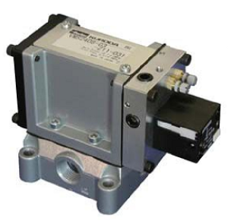ASUs are designed to interrupt the flow of compressed air at intervals that are adjustable up to 5 Hz for pilot-pressure operated units and up to 22 Hz for electronically operated units. This method of flow reduction was not found in any of the other devices that we identified for this report. It results in a series of bursts of air impacting the targeted end use, each burst occurring at a slightly higher pressure than would be expected from a continuous flow of air. ASUs are manufactured by Parker Kuroda, who report potential savings of 40% - 50%.

## Engineered Nozzle

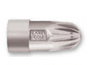Engineered nozzles comprise a wide range of devices designed to address a variety of specific conditions, but all concentrate compressed air flow from a nozzle that entrains ambient air to deliver a mass of air to the target that is greater than the mass of the compressed air alone. It is the increase in mass that more than compensates for a reduction in velocity that the compressed air itself would have, resulting in an increase in force delivered. Adjustable versions are also available, employing calibrated adjustment. Manufacturers include Exair, Silvent, Lechler, Spraying Systems (Windjet), Vortec, Nue Air, Airtx and Streamtek. Savings claims range from 25% to 96%.

## Air Jet

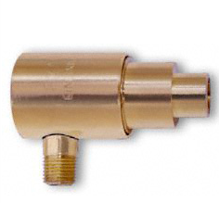Air jets deliver larger volumes of air at lower pressures than engineered nozzles. Compressed air is directed into the bottom of the jet and fed into an annular ring located toward the back of the largest cylinder in the depiction at the left. The front edge of the annular ring is open, directing flow toward the smallest cylinder. The back of the jet is open and ambient air is pulled in by the vacuum that is created. This results in a large mass of air that is more widely dispersed than air from an engineered nozzle and is effective for removing lighter debris that is not sticking tightly to a surface due to electrostatic force, surface tension or other means. Adjustable versions are available, employing shims that can be inserted to increase or removed to decrease the opening of the annular ring, which in turn increases or decreases flow. Manufacturers include Exair, Silvent, Nue Air, Vortec and Streamtec. Savings up to 80% are claimed.

## Air Amplifier

Air amplifiers work on the same principle as air jets but are designed to provide larger volumes of air at lower pressures. This makes them useful for blow-drying and cooling products that have been wetted or heated during manufacture. Adjustable versions are available using the same shimming approach as air jets. Manufacturers include Exair, Spraying Systems (Windjet), Nue Air, Vortec and Streamtek. Savings of 75% to 90% are claimed.

## Air Knife

In air knives, compressed air enters a chamber running the length of the knife. Air blows through a slot, providing a sheet of laminar air to dry, cool or clean products of all shapes and sizes. Efficient designs that entrain surrounding air to augment compressed airflow are available. Shims can be employed to change flow rates in some models. Manufacturers include Exair, Sonic Air Systems, Paxton, Air Control Industries, Republic Manufacturing, Nex Flow and Spraying Systems (Windjet), among others. Savings for efficient air knives are reportedly as much as 65% when compared to air knives of standard design.

## Air Wipes

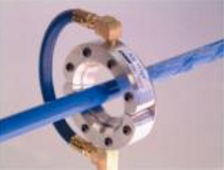Air wipes remove debris and liquids from elongated products such as pipes and cables as they are drawn through the center of the air wipe. Compressed air is supplied to an annular chamber in the wipe and exits via either a continuous slot or series of nozzles mounted on the inside diameter of the wipe. Flow rate and force can be incrementally adjusted in slotted models with shims that allow the width of the slot to be increased or decreased. Manufacturers include Exair, Nex Flow, Keir Manufacturing, Marldon, Air Control Industries and Sonic Air Systems among others. Air wipes are best considered standard practice for the described applications, which means they do not save energy beyond some less efficient baseline condition; however, it is possible that savings might be realized if combined with an ASU.

## Multi-Nozzle Heads

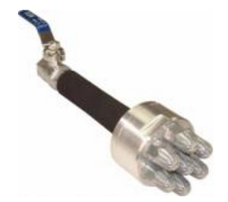Multi-nozzle heads act in the same manner as engineered nozzles but provide considerably greater force through the employment of multiple nozzles mounted on a single head. These devices can be permanently mounted or mounted on an air lance to accommodate manual clearing of quantities of material that accumulate in unwanted areas. An example would be wood chips that fall from certain locations along a long conveyor at a pulp mill.

Applications to which compressed air reducing devices identified in this report could be applied are provided in Figure 1.

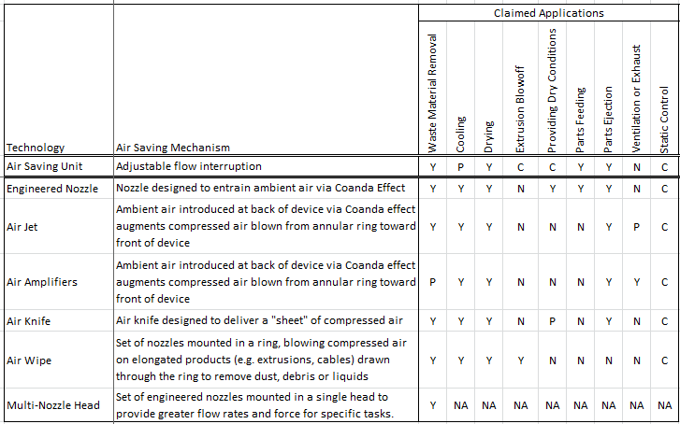

Matrix entry values: Y = Yes

N = No

P = Potentially effective application

C = In combination with additional technology

Figure 1: Matrix showing which energy savings technologies can serve specific compressed air blowing applications

# Devices Competitive with ASUs

ASUs reduce compressed air consumption in blowing end uses by interrupting the flow of air at adjustable rates. ASUs controlled by a pilot pressure can operate at interruption frequencies up to 5 Hz, while electronically-controlled ASUs can operate up to 22 Hz. The theoretical advantage to this approach, as compared to flow-reducing devices based on continuous flow, is that each pulse of air is initiated at a slightly higher pressure than the pressure delivered in a continuous flow. This results in a rapid series of impulses that deliver a momentary increased impact to the target. The adjustability of the frequency and duty cycle (relative durations of ON and OFF flows within a pulse) of the pulses provides an opportunity to “tune” the ASU to the specific end use.

Our investigation into devices competitive with ASUs uncovered several that reduce flow but none that interrupt flow to achieve that reduction. In addition to those listed in Section 5, an additional device was brought to our attention that did interrupt flow, however, the flow that was interrupted was the exhaust from an actuator. While this device does appear to provide savings and flow is interrupted, it is not applicable to blowing end uses and therefore is not competitive with ASUs.

# Performance Specification Development Feasibility

One of the goals of this investigation is to identify the potential use of a category of energy efficient devices that could be applied similarly to ASUs in terms of end uses addressed, operating principle and intended effects. To ensure this objective is met it will be necessary to develop a performance specification (specification) to be applied in the acceptance of any device falling within this category to be approved for use in utility efficiency programs in the Northwest.

A broad set of manufacturers and utility representatives should be convened to review the specification and provide feedback as its development progresses. Consideration should also be given to designing the specification such that it can be updated as technologies and the marketplace evolve.

The specification should address devices mounted in-line and capable of operating either as the sole flow-reducing device for a given end use or in concert with other devices mounted downstream of the subject device. A spectrum of blowing end uses exists in compressed air systems, ranging from categories that occur commonly to those that can be considered one-of-a-kind. Different end uses can have different requirements with respect to the effect to be achieved. Because the desired effects may impose different performance requirements, consideration of those differences should be given to common end uses, such as those indicated in this report.

We believe that such a performance specification can be developed. A suggested high-level outline follows:

1. Background
   1. Description of advantages and disadvantages of using compressed air
   2. Use of compressed air for blowing applications
   3. Industry attempts to reduce compressed air energy consumption
2. Purpose of the performance specification
3. Scope
   1. General description of the device and its operating principle
   2. Applications of the device
   3. Factors affecting device performance (e.g. system pressure)
4. Device requirements
   1. Adherence to existing regulations (e.g. OSHA)
   2. Installation considerations
      1. Allowable range of operating pressures
      2. Device adjustability
   3. Warranty
   4. Repair information (e.g. parts lists, parts sources, repair procedures, contacts)

# Recommendations

Based on the findings in this report we recommend the following:

* Field test ASUs

Field testing ASUs prior to preparing a performance specification is critical step that will provide insights into the capabilities as well as installation and setup requirements of similar devices. Field testing will require recruitment of sites willing to participate. As part of the recruitment process, once a potential participant is identified, a phone interview would be completed to make sure the candidate understands the testing scope, has at least one qualifying blowing end and is willing to commit the resources necessary to complete the field test.

Following the phone interviews, a set of site visits would be made to those sites considered most advantageous for testing. The purpose would be to verify the intended end use(s) as feasible, and to provide more detail to the participant if desired.

From the visited sites, a final list of participants would be compiled and each participant would be asked to sign a participation agreement spelling out the responsibilities of the sponsoring agency, SBW Consulting and the participant.

Following execution of the participation agreements, preparation for field testing would commence, followed closely by equipment installations at the participating sites. Feedback from the participants regarding effectiveness of achieving the intended effect at the end use, ease of use and the likelihood of incorporating ASUs to address blowing applications would be sought from site staff.

Recorded data and staff interviews would be analyzed to quantify effects on compressed air consumption and the resulting energy impacts. Interview data would also be compiled and case studies prepared for each participating site and a summary report.

* Prepare a performance specification for compressed air reducing devices based on flow interruption

Insights gained from field testing of ASUs can inform the decision to proceed with a performance specification that could be used to qualify devices such as ASUs for inclusion in utility conservation programs. This specification should be prepared with reviews and feedback from manufacturers and utility representatives to ensure their concerns and perspectives are addressed.

* Development of RTF measures

Following completion of the specification, RTF measures should be developed that can then be used as the basis of specific utility efficiency programs.

* Informational and educational outreach

Materials, methods and strategies could be developed for disseminating information about the availability of efficient devices, the specification defining the performance of those devices and utility efficiency programs that take advantage of them. This information could be presented to compressed air system designers, vendors and auditors as well as specific utility customers, especially those who operate and maintain compressed air systems.